

**BITI1113**

**ARTIFICIAL INTELLIGENCE**

**ASSIGNMENT 2**

**PREPARED FOR**

DR. NUR ZAREEN BINTI ZULKARNAIN

**PREPARED BY**

MUHAMMAD NURHAFIZI BIN ABU BAKAR SEDAK

B031810386

2 BITS S1G2

# Table of Content

Table of Content I

Table of Figures II

Training Data 1

Test Result 4

Class Anger 4

Class Disgust 5

Class Fear 6

Class Happiness 7

Class Sadness 8

Class Surprise 9

Self-Review 10

# Table of Figures

Figure 1 Sample for class Anger 1

Figure 2 Sample for class Disgust 1

Figure 3 Sample for class Fear 2

Figure 4 Sample for class Happiness 2

Figure 5 Sample for class Sadness 3

Figure 6 Sample for class Surprise 3

Figure 7 Test result #1 for class Anger 4

Figure 8 Test result #2 for class Anger 4

Figure 9 Test result #1 for class Disgust 5

Figure 10 Test result #2 for class Disgust 5

Figure 11 Test result #1 for class Fear 6

Figure 12 Test result #2 for class Fear 6

Figure 13 Test result #1 for class Happiness 7

Figure 14 Test result #2 for class Happiness 7

Figure 15 Test result #1 for class Sadness 8

Figure 16 Test result #2 for class Sadness 8

Figure 17 Test result #1 for class Surprise 9

Figure 18 Test result #2 for class Surprise 9

# Training Data

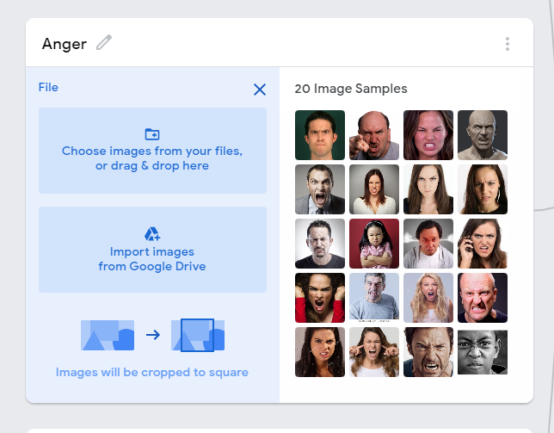

Figure 1 Sample for class Anger

Figure 1 shows the sample data for class Anger. The class consist of 20 different picture that express the emotion of anger.

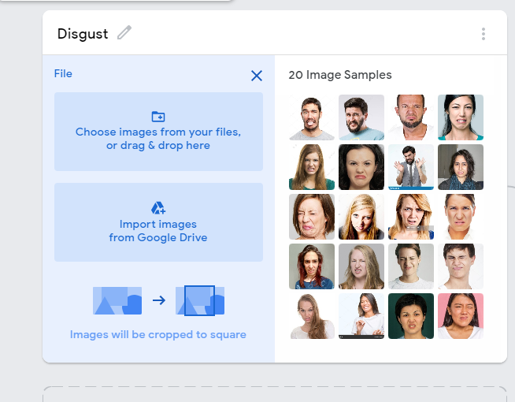

Figure 2 Sample for class Disgust

Figure 2 shows the sample data for class Disgust. The class consist of 20 different picture that express the emotion of disgust.

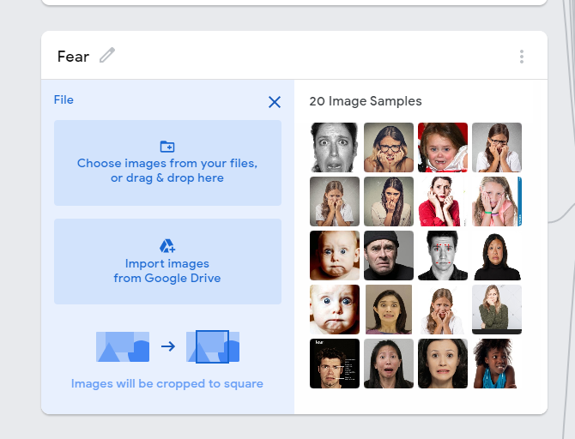

Figure 3 Sample for class Fear

Figure 3 shows the sample data for class Fear. The class consist of 20 different picture that express the emotion of fear.

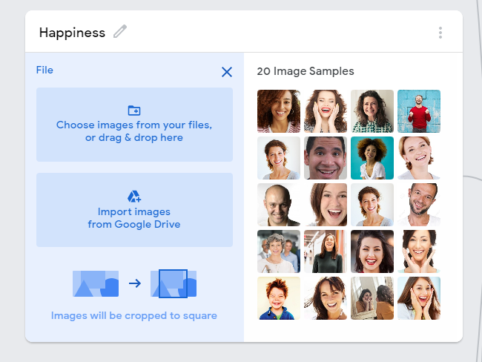

Figure 4 Sample for class Happiness

Figure 4 shows the sample data for class Happiness. The class consist of 20 different picture that express the emotion of happiness.

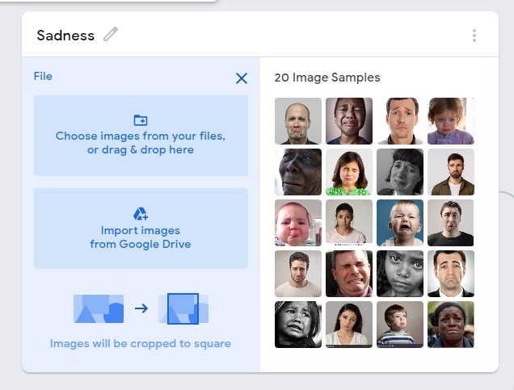

Figure 5 Sample for class Sadness

Figure 5 shows the sample data for class Sadness. The class consist of 20 different picture that express the emotion of sadness.

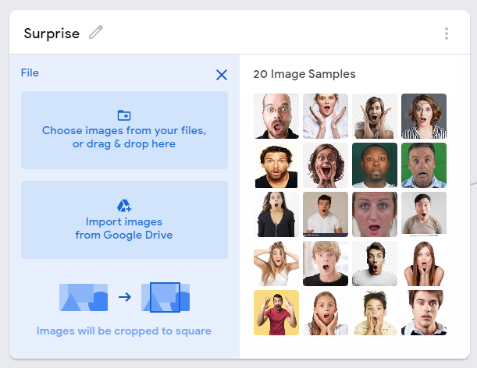

Figure 6 Sample for class Surprise

Figure 6 shows the sample data for class Surprise. The class consist of 20 different picture that express the emotion of surprise.

# Test Result

## Class Anger

|  |  |
| --- | --- |
| Anger 1  Figure 7 Test result #1 for class Anger | Anger 2  Figure 8 Test result #2 for class Anger |

Figure 7 shows that 70% of the facial expression is belongs to class Anger, 24% is belongs to class Happiness, 4% is belongs to class Disgust and 1% is belongs to class Sadness and Surprise.

Figure 8 shows that 98% of the facial expression is belongs to class Anger and the rest is belongs to class Surprise.

Both figures show the highest percentage of anger detected from both facial expression. This shows that the model has high accuracy in detecting anger based on facial expression.

## Class Disgust

|  |  |
| --- | --- |
| Disgust 1  Figure 9 Test result #1 for class Disgust | Disgust 2  Figure 10 Test result #2 for class Disgust |

Figure 9 shows that 93% of the facial expression is belongs to class Disgust, 5% is belongs to class Sadness and 1% is belongs to class Surprise and Fear.

Figure 10 shows that 40% of the facial expression is belongs to class Disgust, 23% is belongs to class Sadness, 22% is belongs to class Anger and the rest is belongs to class Happiness, Surprise and Fear.

Both figures show that the highest percentage of disgust detected form both facial expression. This shows that the model has high accuracy in detecting disgust based on facial expression.

## Class Fear

|  |  |
| --- | --- |
| Fear 1  Figure 11 Test result #1 for class Fear | Fear 2  Figure 12 Test result #2 for class Fear |

Figure 11 shows that 82% of the facial expression is belongs to class Fear, 9% is belongs to class Surprise, 4% is belongs to class Anger, 2% is belongs to class Sadness and Happiness and 1% is belongs to class Disgust.

Figure 12 shows that 61% of the facial expression is belongs to class Fear, 37% is belongs to class Sadness and 1% is belongs to class Happiness and Surprise.

Both figures show that the highest percentage of fear is detected form both facial expression. This shows that the model has high accuracy in detecting fear based on facial expression.

## Class Happiness

|  |  |
| --- | --- |
| Happy 1  Figure 13 Test result #1 for class Happiness | Happy 2  Figure 14 Test result #2 for class Happiness |

Figure 13 shows that 76% of the facial expression is belongs to class Happiness, 17% is belongs to class Anger, 3% is belongs to class Fear and 2% is belongs to class Surprise and Disgust.

Figure 14 shows that 98% of the facial expression is belongs to class Happiness and the rest belongs to class Surprise, Fear and Disgust.

Both figures show that the highest percentage of happiness is detected from both facial expression. This shows that the model has high accuracy in detecting happiness based on facial expression.

## Class Sadness

|  |  |
| --- | --- |
| Sadness 1  Figure 15 Test result #1 for class Sadness | Sadness 2  Figure 16 Test result #2 for class Sadness |

Figure 15 shows that 77% of the facial expression is belongs to class Sadness, 20% is belongs to class Surprise and the rest is belongs to class Anger and Fear.

Figure 16 shows that 99% of the facial expression is belongs to class Sadness and the rest belongs to other classes.

Both figures show that the highest percentage of sadness is detected from both facial expression. This shows that the model has high accuracy in detecting sadness based on facial expression.

## Class Surprise

|  |  |
| --- | --- |
| Surprise 1  Figure 17 Test result #1 for class Surprise | Surprise 2  Figure 18 Test result #2 for class Surprise |

Figure 17 shows that 89% of the facial expression is belongs to class Surprise and the rest is belongs to class Happiness, Fear and Disgust.

Figure 18 shows that 58% of the facial expression is belongs to class Surprise, 30% is belongs to class Anger, 9% is belongs to class Fear and 1% is belongs to class Sadness, Happiness and Disgust.

Both figures show that the highest percentage of surprise is detected for both facial expression. This shows that the model has high accuracy of detecting surprise based on facial expression.

# Self-Review

1. **How well did the AI recognize emotions?**

AI did an excellent job in recognizing emotion with just a few sample of facial expression. However I believe that with a few improvement, AI can learn a lot more and will be able to do a better job at recognizing emotions.

1. **Could the AI recognize other people’s emotion using your setup? Why or why not?**

By using my setup which is supported by Teachable Machine provided by Google, with just 20 sample of facial expression for every class, the AI is able to recognize other people emotions. This is because the AI learned by detecting similarities of every sample in a class and differentiate the sample from other classes. In my opinion, the AI will have higher accuracy in detecting emotions by increasing the number of sample.

1. **Sometimes we hide our emotions. What others see on our outside is not always how we are feeling on the inside. Would the AI be able to recognize our emotions if we were hiding them?**

In my opinion, the AI would not be able to detect the emotions if we were hiding it. This is because facial expression is not enough to detect a person emotion. The AI need to observe the combination of facial expression, body language and behaviour of someone in order to detect hidden emotion accurately. I believe in future AI will be able to do so.